**Make a giraffe with a long neck on a bendy straw!!**

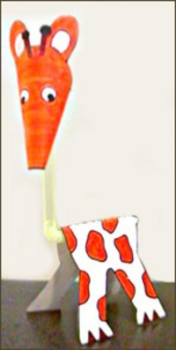

Print these shapes on to card.

Colour them and cut them out,

The stick the head to one end of a bendy straw and the body over the other end.

And don’t forget to add the horns!

