[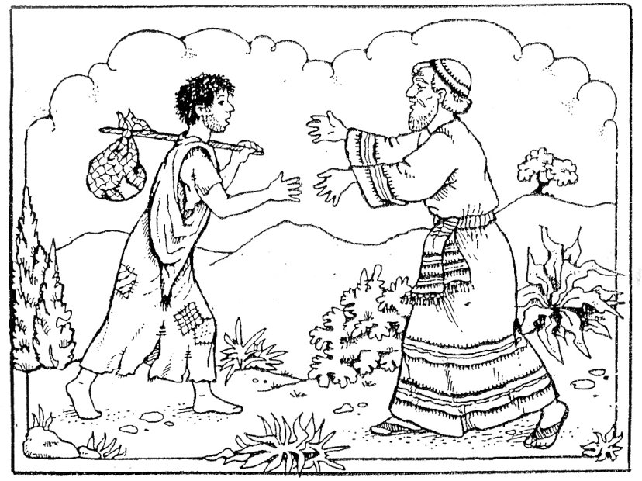](https://www.google.com/url?sa=i&rct=j&q=&esrc=s&source=images&cd=&ved=0ahUKEwjtpbnr6PTUAhWDPRQKHfzVDgUQjRwIBw&url=https://www.pinterest.com/pin/354236326917558935/&psig=AFQjCNHoVrSlKVXmO6C0Ec4EVY7_eLq5AQ&ust=1499436079002745)